P3 Design and Description

Xiaohui Chen

[xhchen0328@utexas.edu](mailto:xhchen0328@utexas.edu)

Jianyu Huang

[jianyu@cs.utexas.edu](mailto:jianyu@cs.utexas.edu)

Here are all the features of BMW 2 Series:

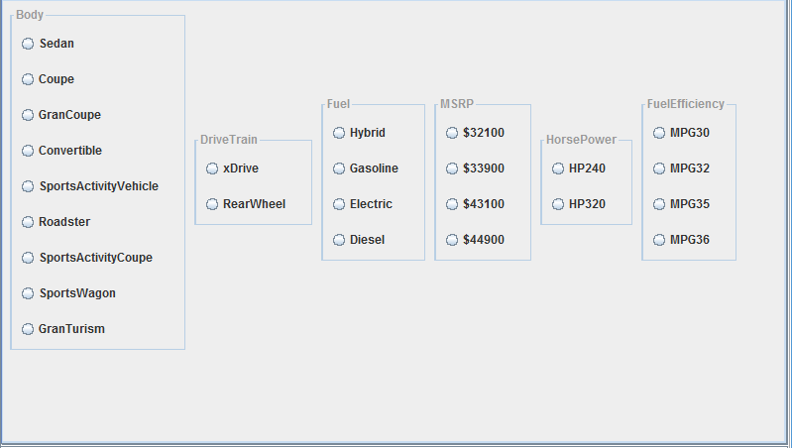

The feature model is designed in model.xml. In reality we discover that only one features in a parent feature can be selected (chooseone constraint). We do not discover any cross-tree constraints.

In addition to the feature model, we also created the four BMW 2 series products in the configuration files. Each configuration corresponds to one product. As a matter of fact, all the 4 products can be fully described by the feature model.